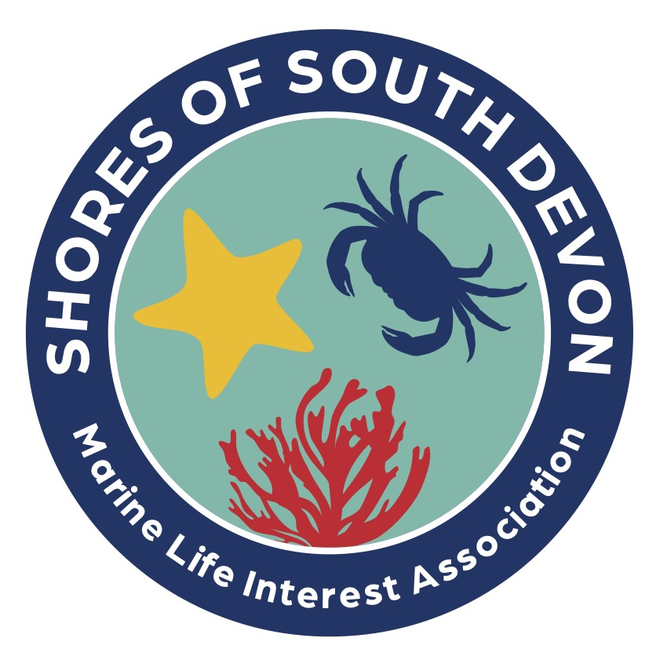

Shoresearch Walkover Survey

Health & Safety Declaration

- I understand that my decision to participate in this activity is my sole responsibility.
- I agree not to hold the Shores of South Devon or any of its volunteers liable for any injury, damage or loss suffered while engaged in this survey (unless such injury, loss or damage was caused by, or resulted from, negligence or deliberate act).
- I accept responsibility for my personal conduct while participating on a shore survey and I will adhere to the Shores of South Devon code of good practice (turn stones back, avoid crushing animals, use nets carefully, avoid habitat disturbance, leave no litter and avoid seals and seabirds).
- I understand that Shores of South Devon volunteers cannot be responsible for, or supervise, any children that attend, and I will register and take full responsibility for any in my care.
- I understand that shore surveys have their attendant risks and that the Shores of South Devon can only provide assistance during the hours of the survey and that it not required to exercise supervision or advice outside those hours.
- I understand that the Shores of South Devon does not accept responsibility for anyone not registered for this shore survey.
- I have disclosed any medical problems that might possibly affect me during the course of a Shores of South Devon survey and I give permission to the organisers to seek medical assistance, and administer any relevant treatment or medication that I provide, if necessary.
Finally:
Please sign the attendance sheet to show that you have read this declaration.

This version: 27th July 2023

